 WORKSHEET-1

**AIM:**

Hands on session on breadboard and simulation software.

**REQUIREMENTS:**

PC with Arduino, Connecting Wires, Breadboard, Resistances, Battery, LED’s.

**CIRCUIT DIAGRAM:**

**1**

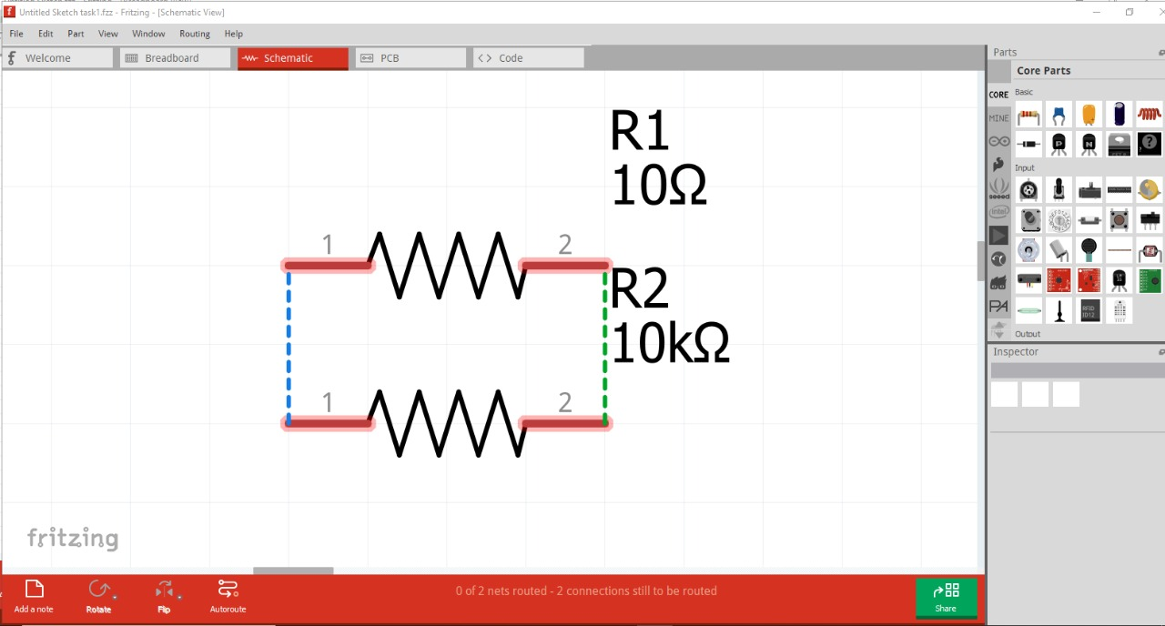

**2.**

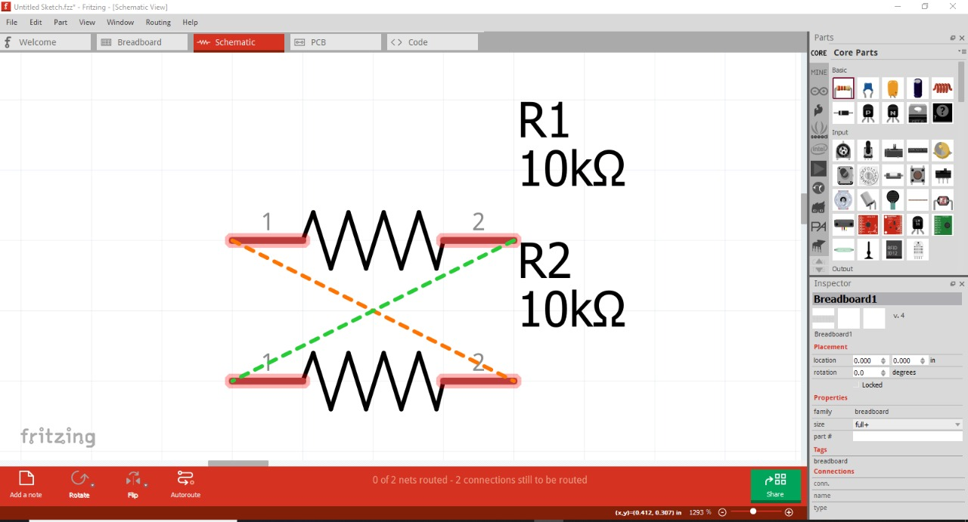

**3.**

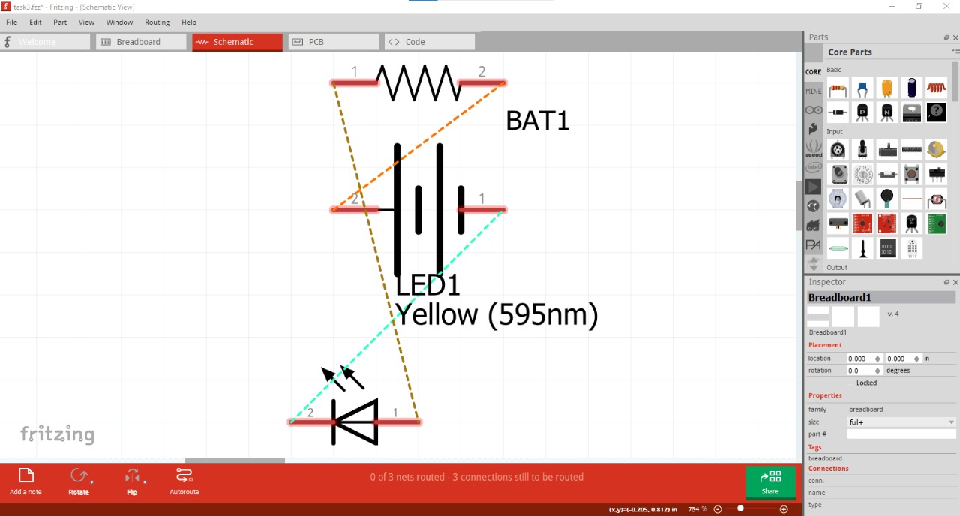

**4.**

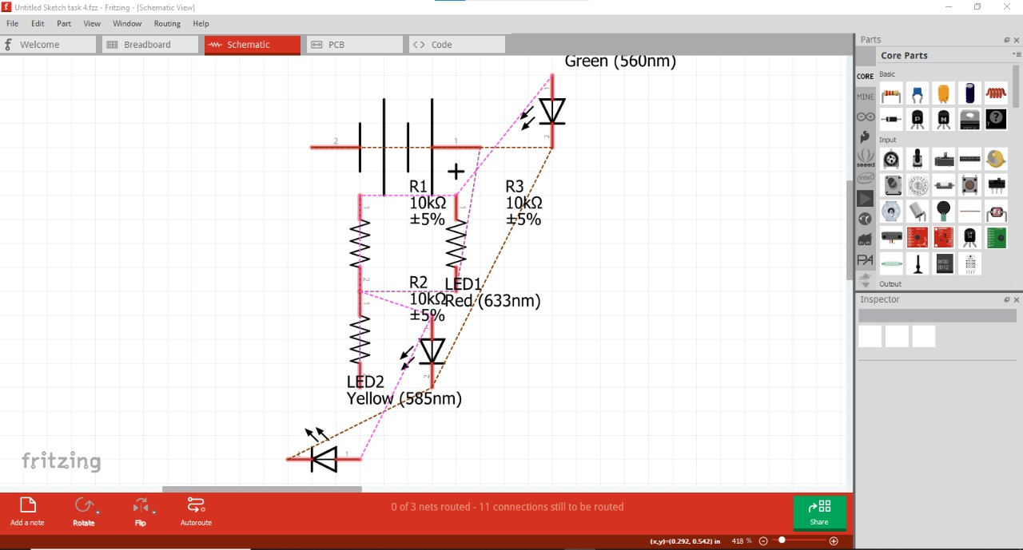

**SIMULATIONS:**

**1.**

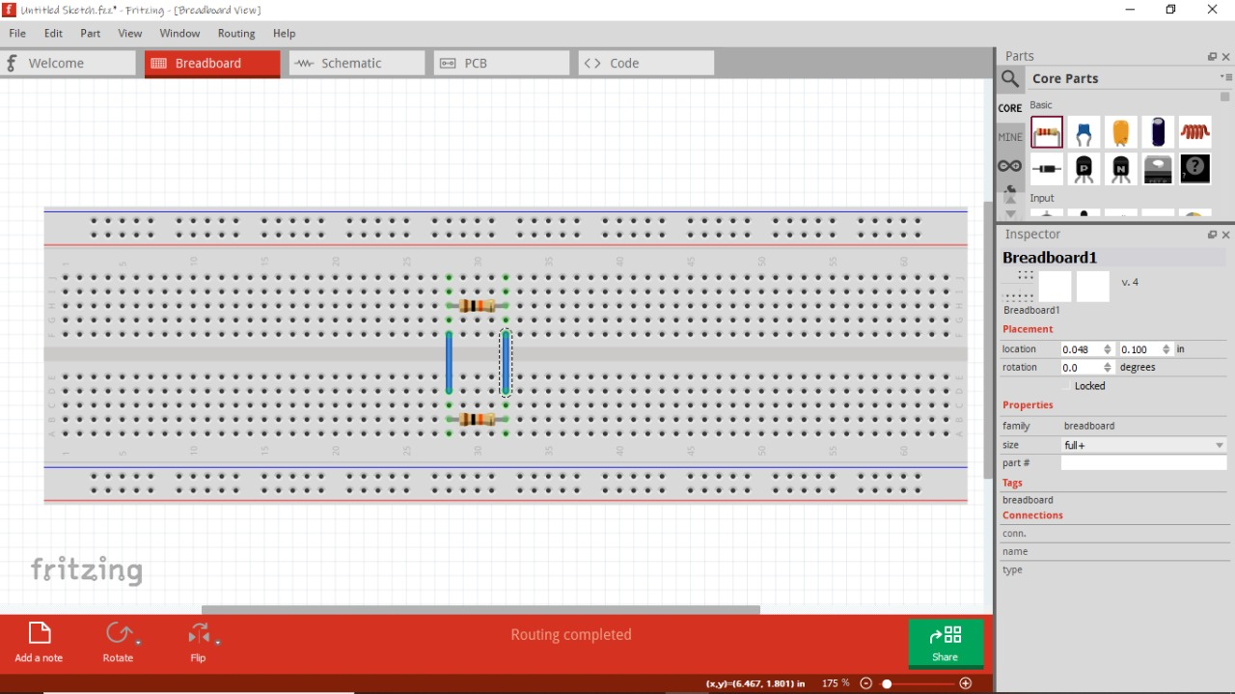

**2.**

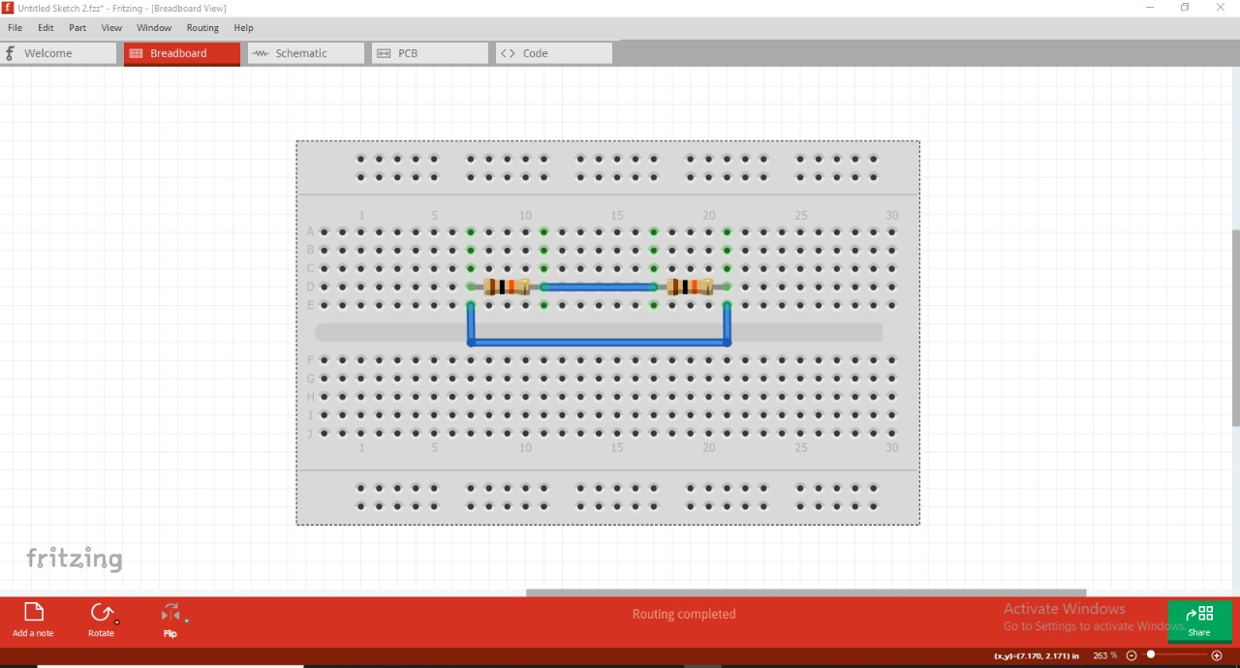

**3.**

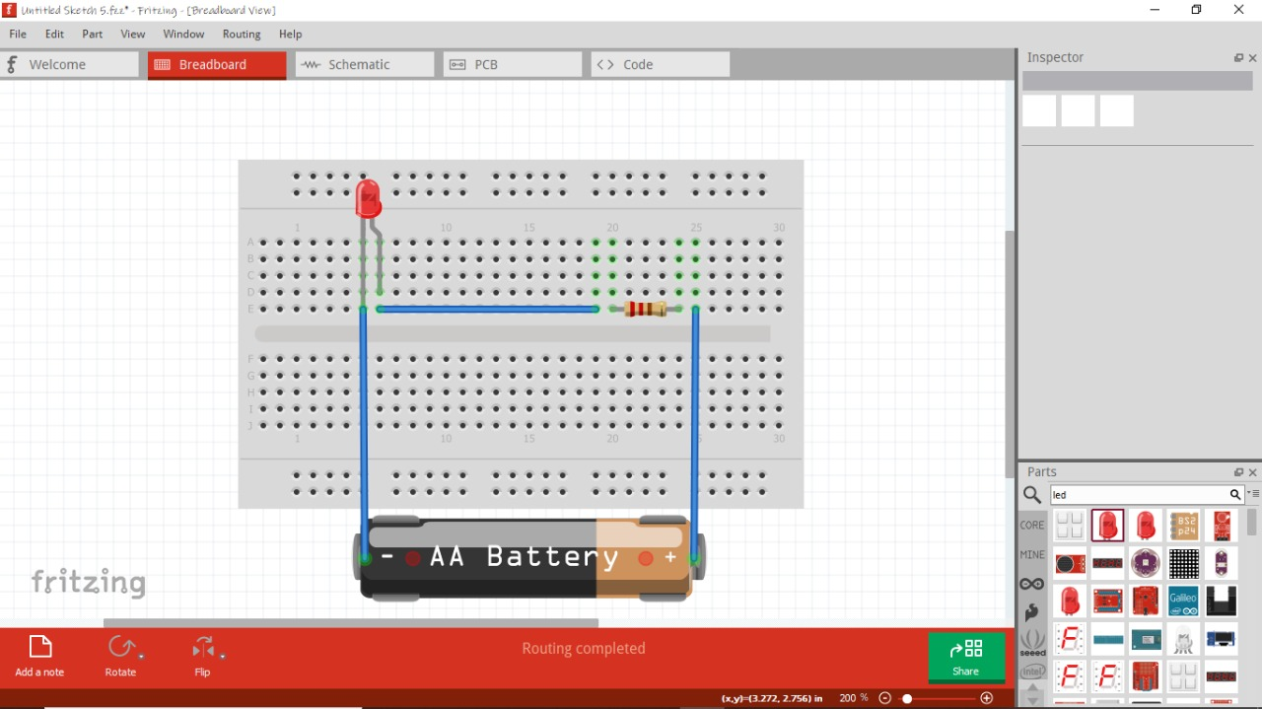

**4.**

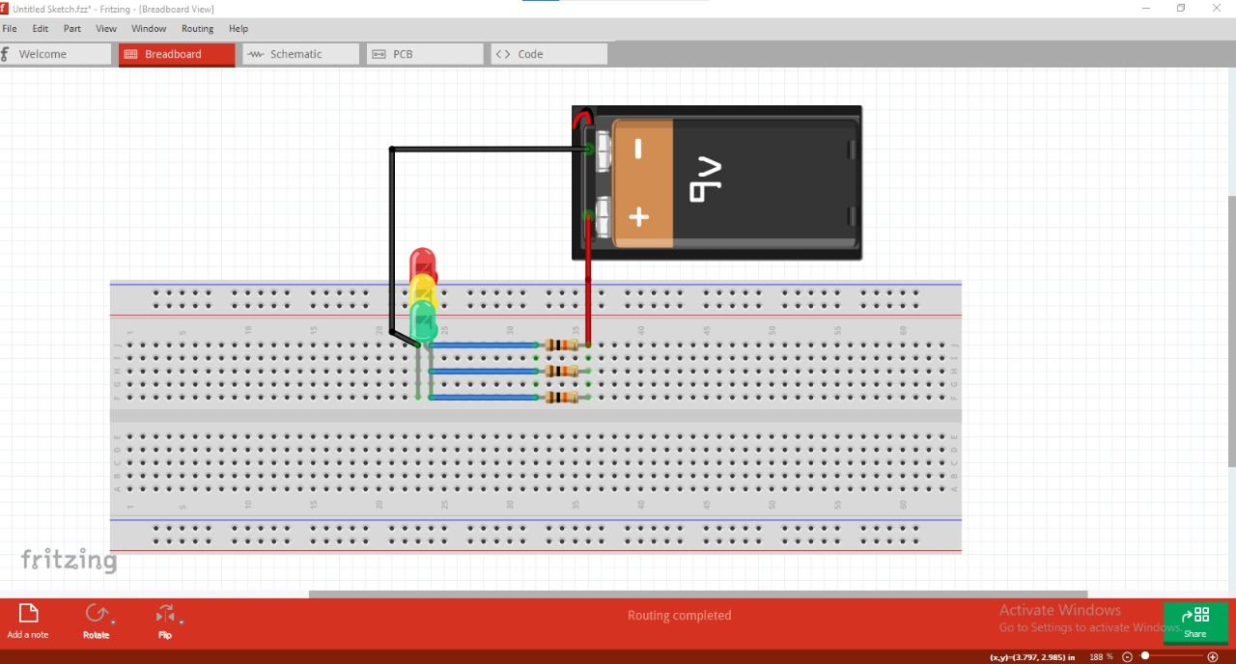

**DASHBOARD SNIPPET (if any):**

**Nil**

**OUTCOMES:**

# WORKSHEET-2

**Task:**

Hands-on session on Breadboard and Simulation Software.

## Requirements:

* PC WITH ARDUINO, CONNECTING WIRES ,BREADBOARD, RESISTORS, POWER SUPPLY, LIGHT EMITTING DIODE’S

**Circuit Diagram:**

**TASK 1**

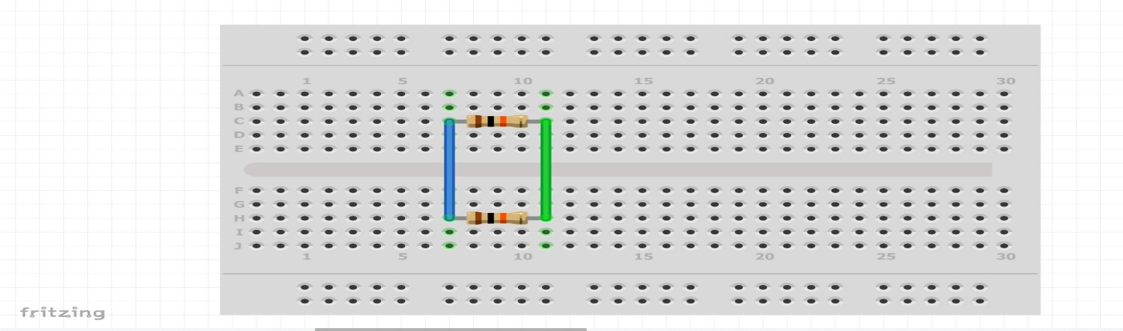

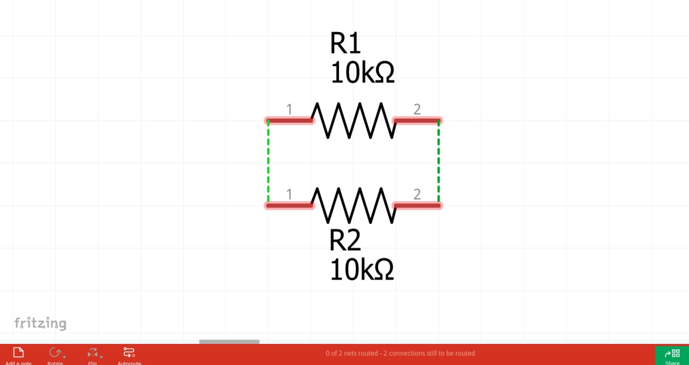

**TASK 2**

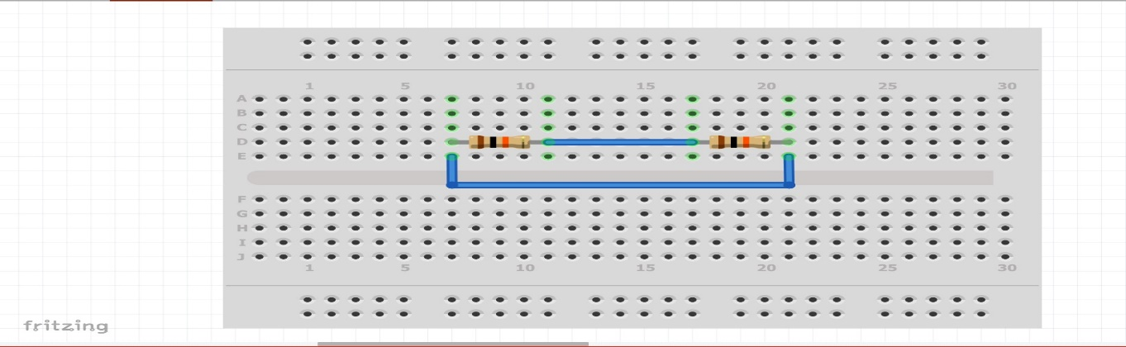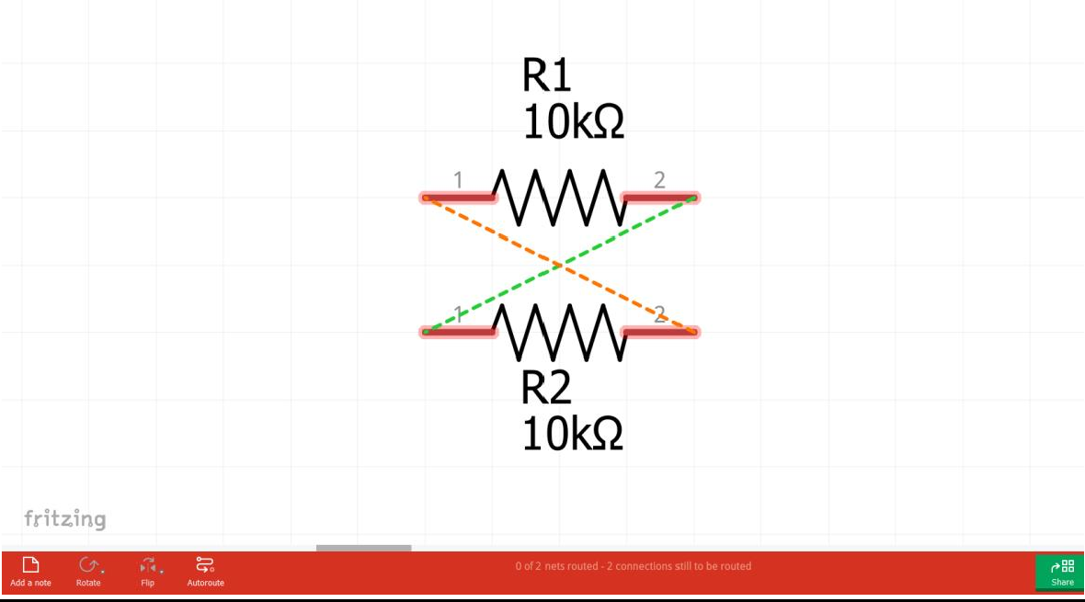

# TASK 3

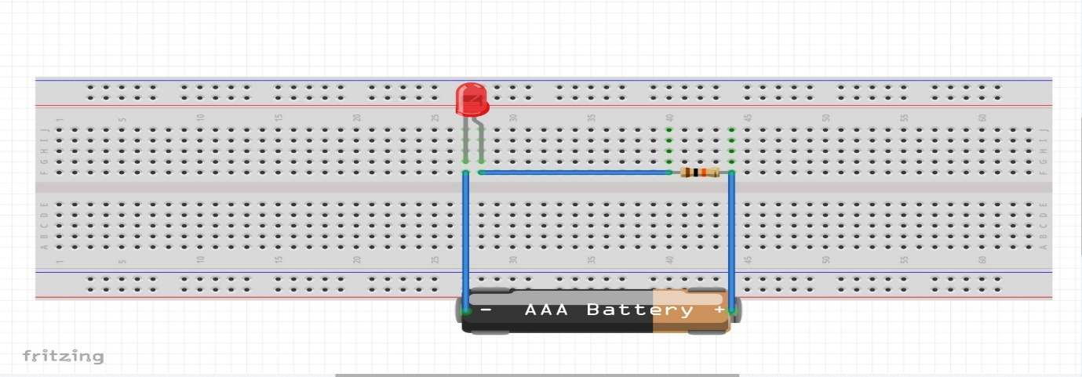

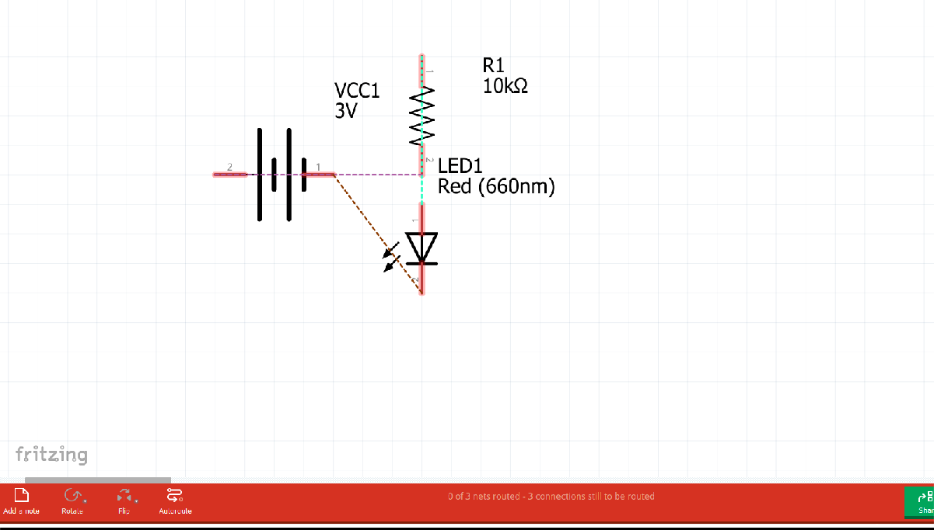

**TASK 4**

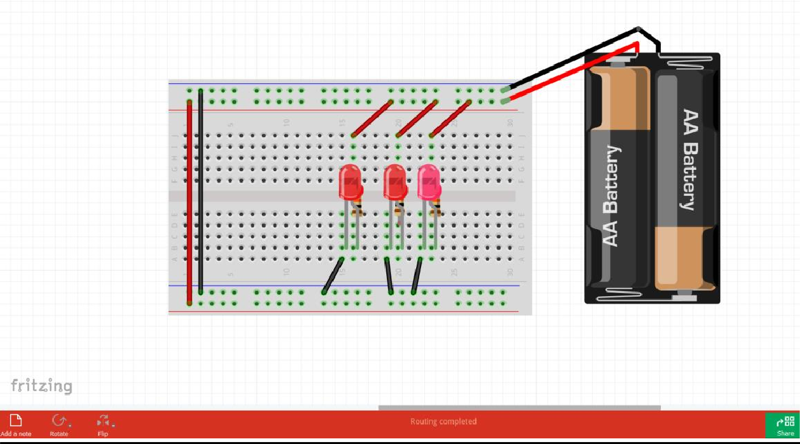

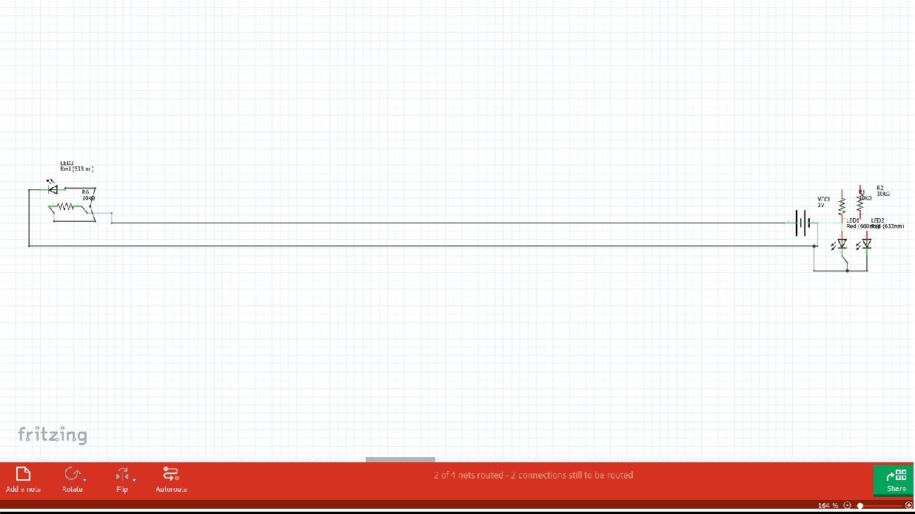

# WORKSHEET-3

# Task:

Hands-on session on Breadboard and Simulation Software.

## Requirements:

* PC WITH ARDUINO, CONNECTING WIRES, BREADBOARD, DOIT ESP32 DEVKIT V1, 10 uF ELECTROLYTIC CAPACITOR, WIRE CLIPPER, USB TYPE A TO MICRO USB CABLE, DC 5V POWER SUPPLY, DC 3.3V POWER SUPPLY, LED,1 Kohm RESISTOR

**Circuit Diagram:**

**TASK 1**

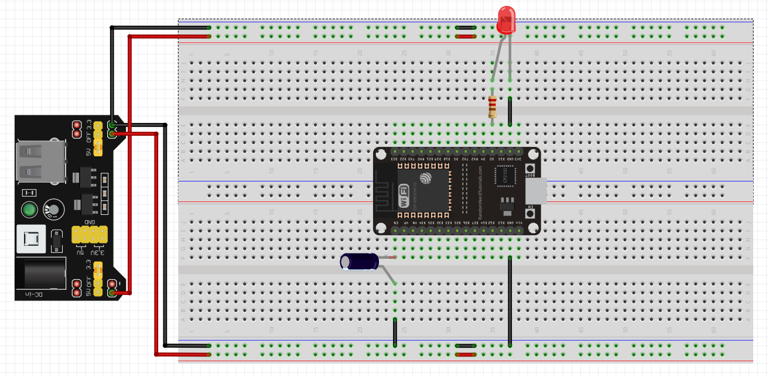

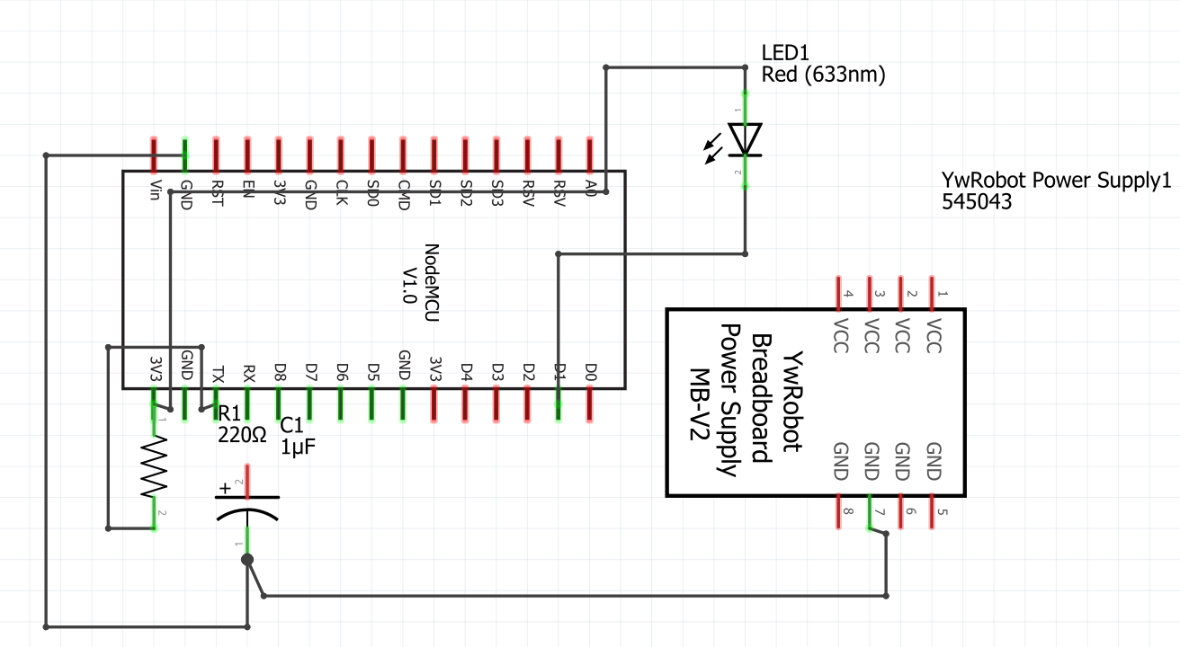

**Code:**

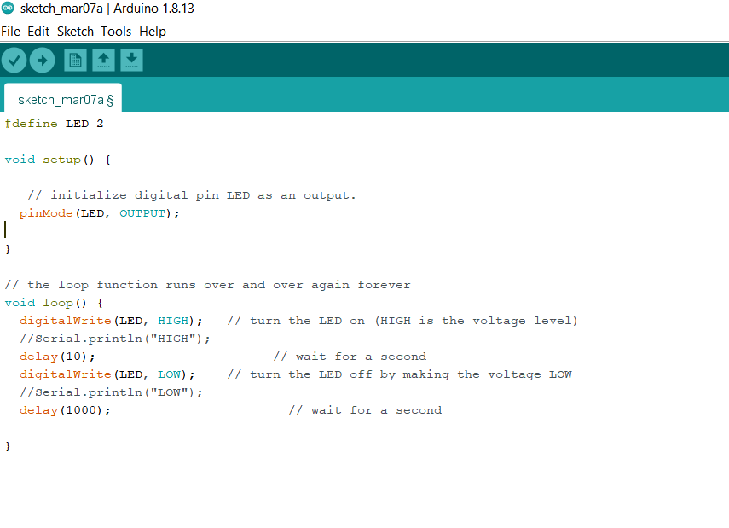

# WORKSHEET-4

# TASK

Design a Cloud based weather monitoring system using IoT platform and relevant sensors.

## Requirements:

* PC with Arduino, Connecting Wires, Breadboard, DOIT ESP32 DEVKIT V1, 10uF Electrolytic Capacitor, Wire Clipper, USB Type A to Micro USB Cable, DC 5V Power Supply, DC 3.3V Power Supply, BMP280

**Code:**

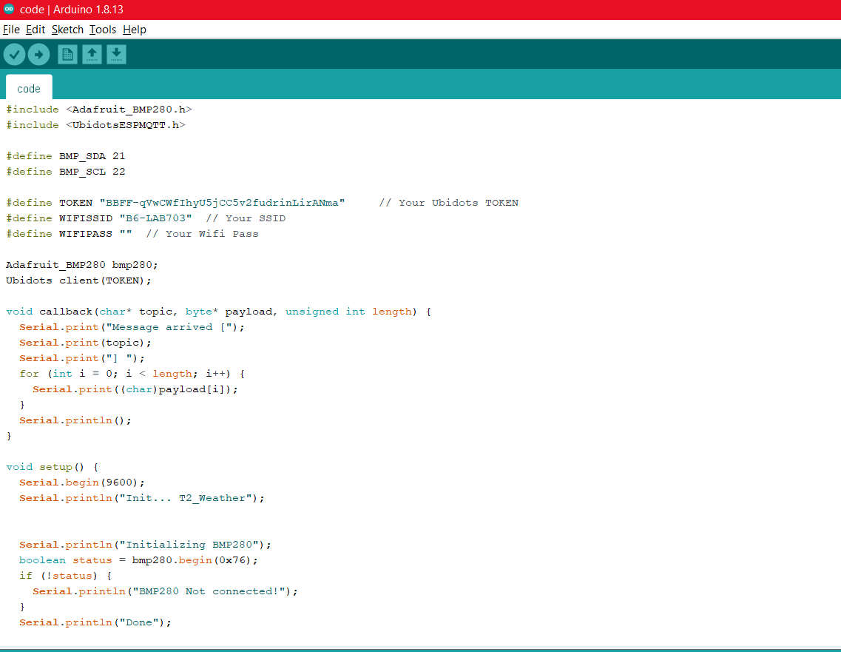

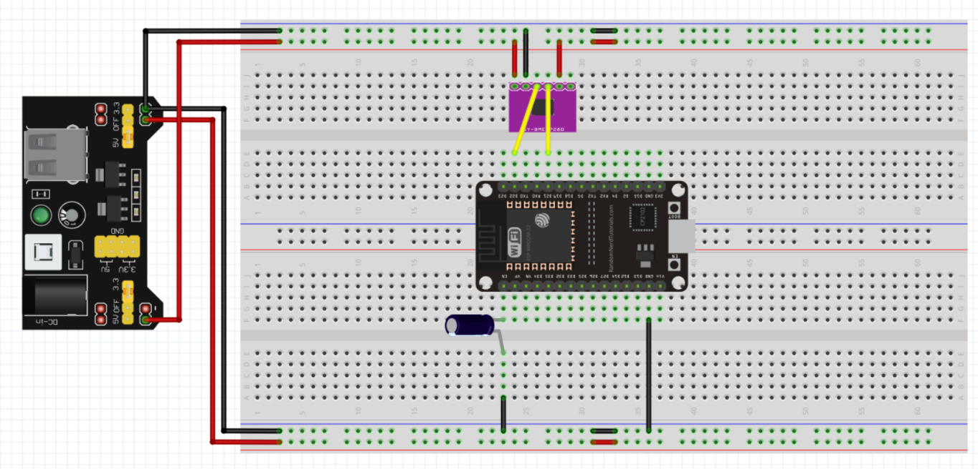

**Outcome:**

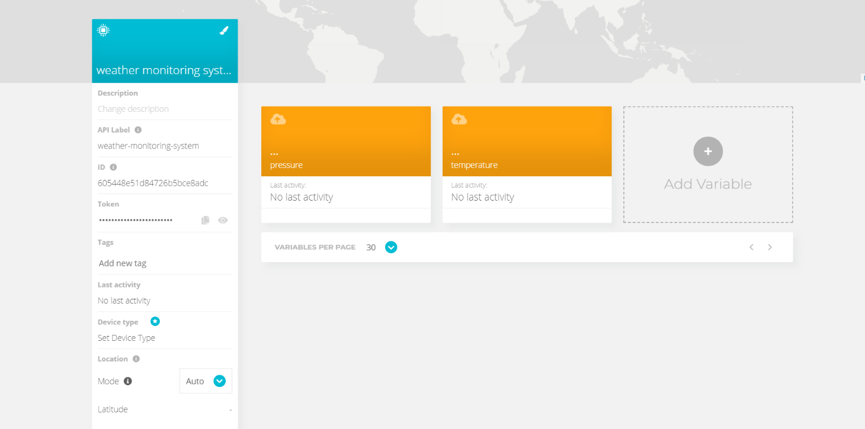

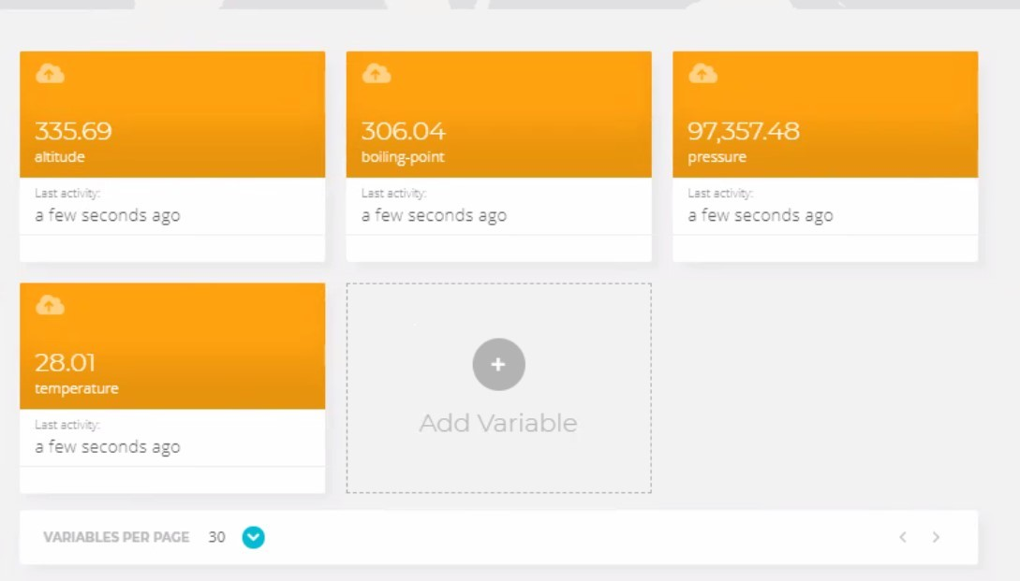

# WORKSHEET-5

# Task:

Develop a smart phone application for smart home voice-assistant.

## Requirements:

* PC with Arduino, Connecting Wires, Breadboard, DOIT ESP32 DEVKIT V1, 10uF Electrolytic Capacitor, Wire Clipper, USB Type A to Micro USB Cable, DC 5V Power Supply, DC 3.3V Power Supply, 5v Relay, Light Bulb, AC Plug (Male)

**Code:**

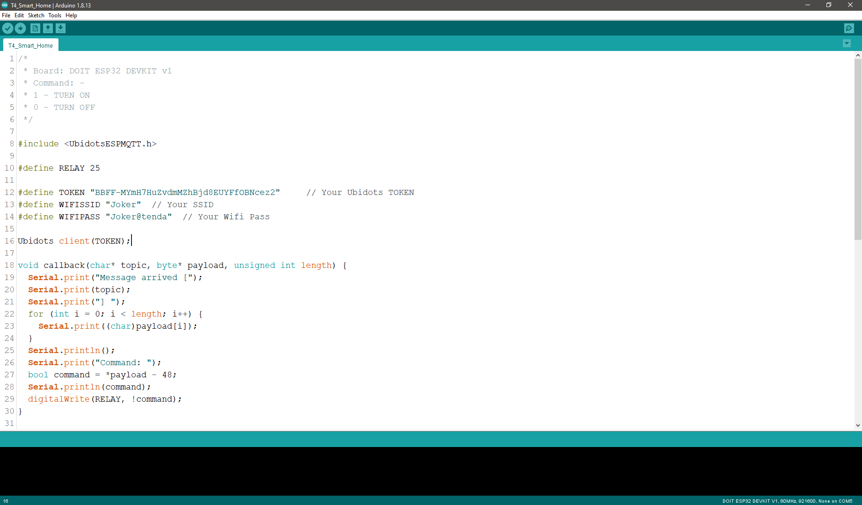

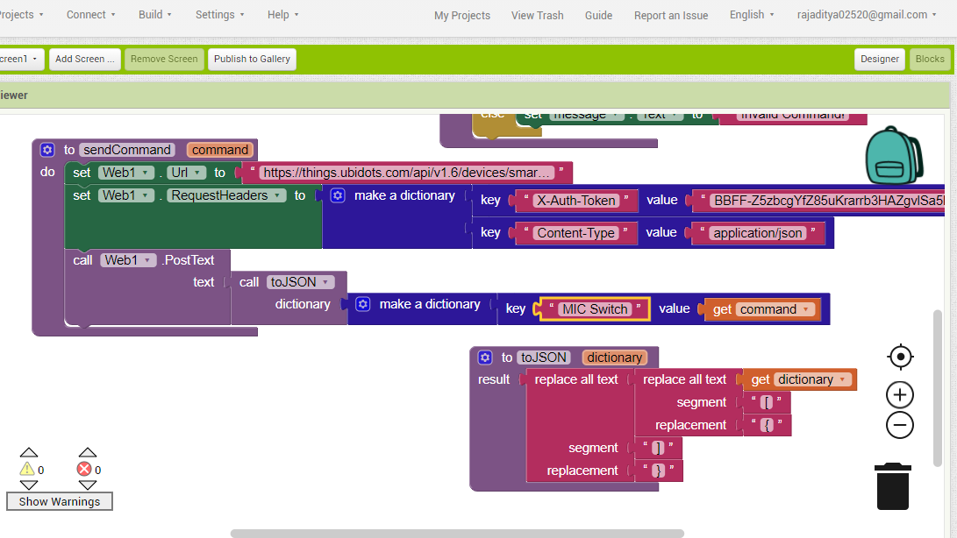

**Outcome:**

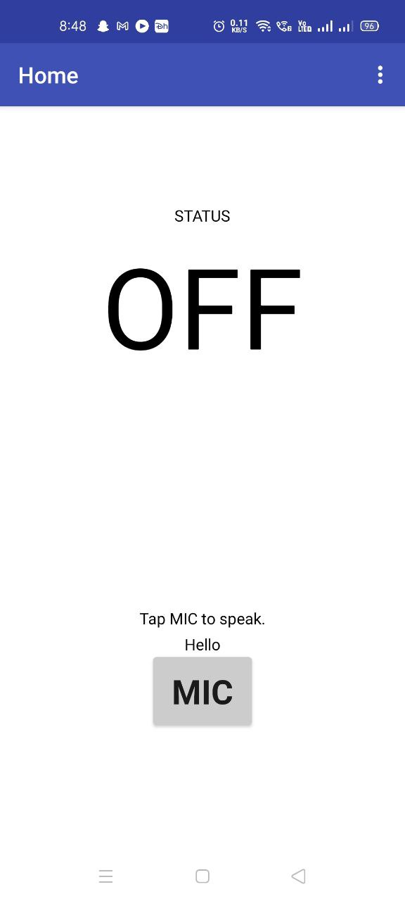

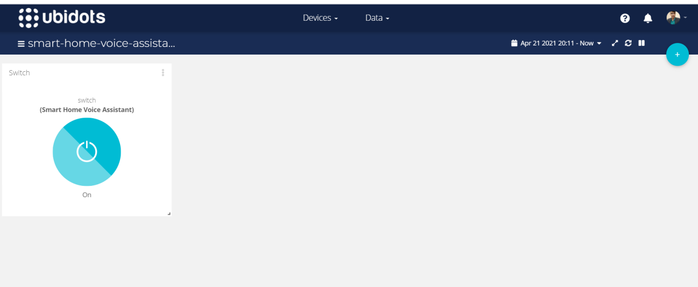

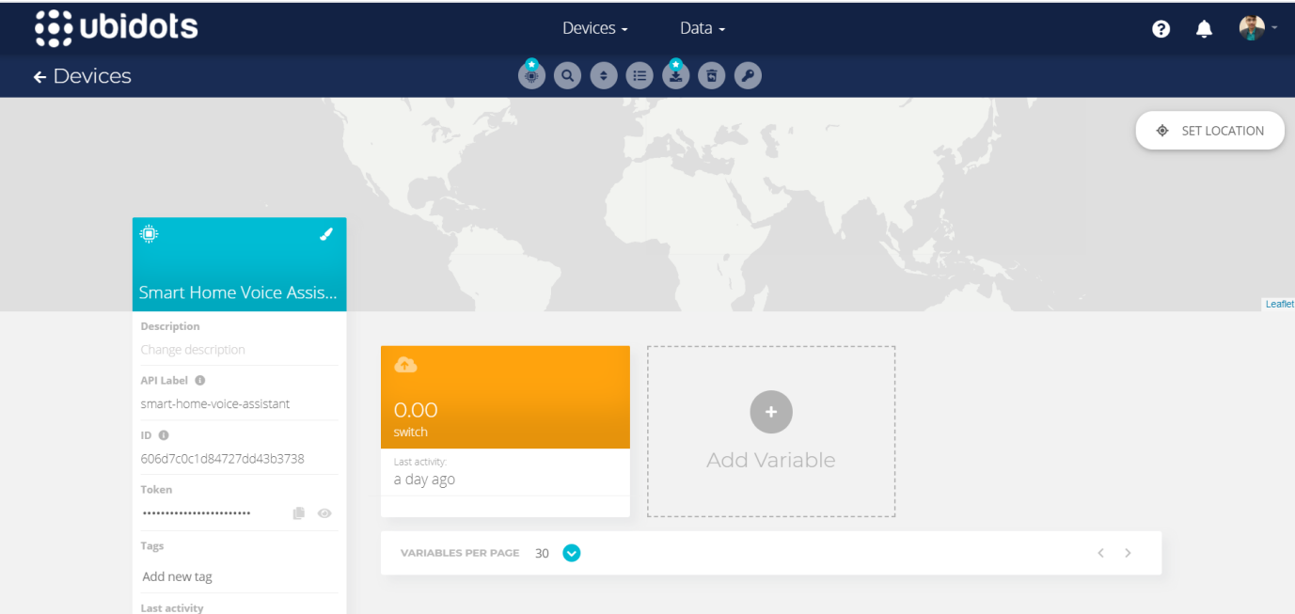

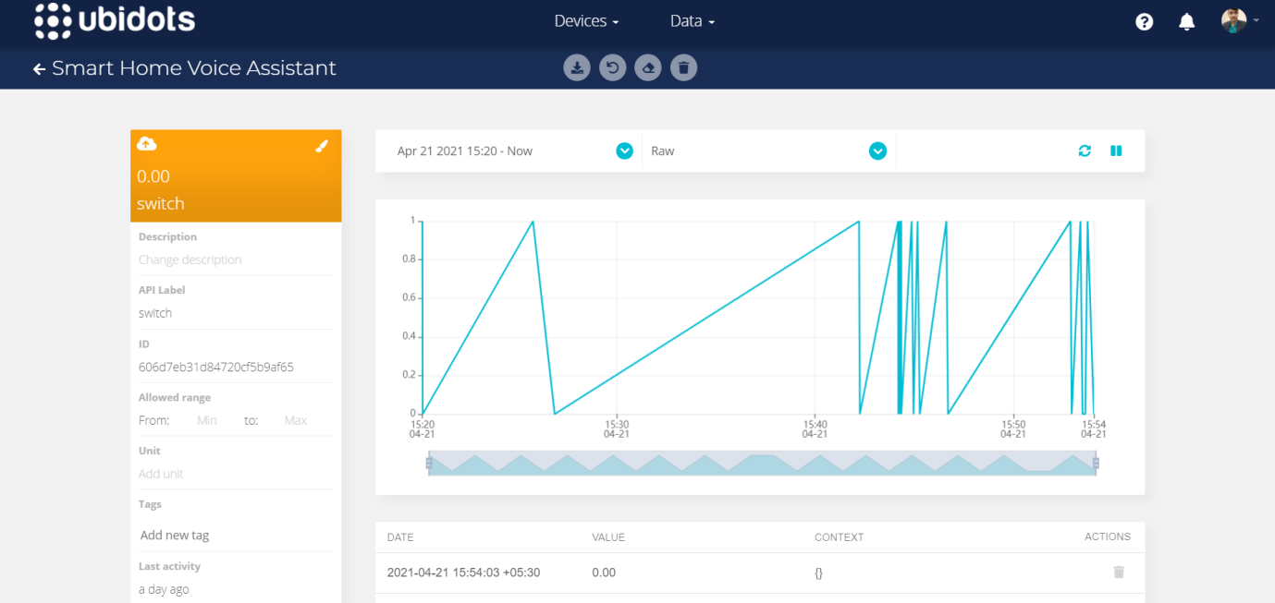

# WORKSHEET-6

**Task:**

Develop a smart phone application for close range wireless robot motion control.

## Requirements:

* PC with Arduino, Connecting Wires, Breadboard, DOIT ESP32 DEVKIT V1, 10uF Electrolytic Capacitor, Wire Clipper, USB Type A to Micro USB Cable, DC 5V Power Supply, DC 3.3V Power Supply, L293D Motor Driver, 2 piece - DC Motors

**Code:**

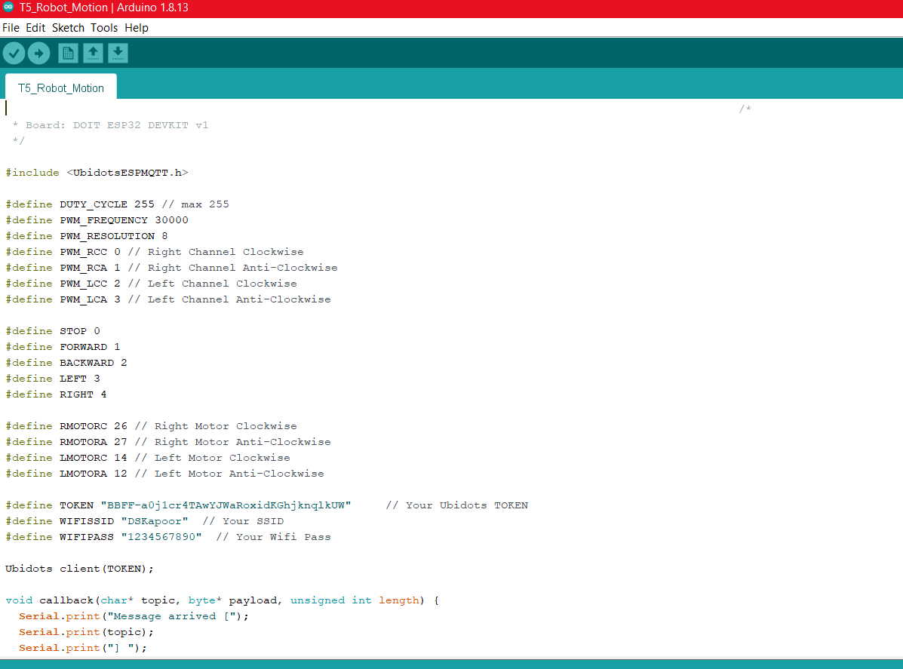

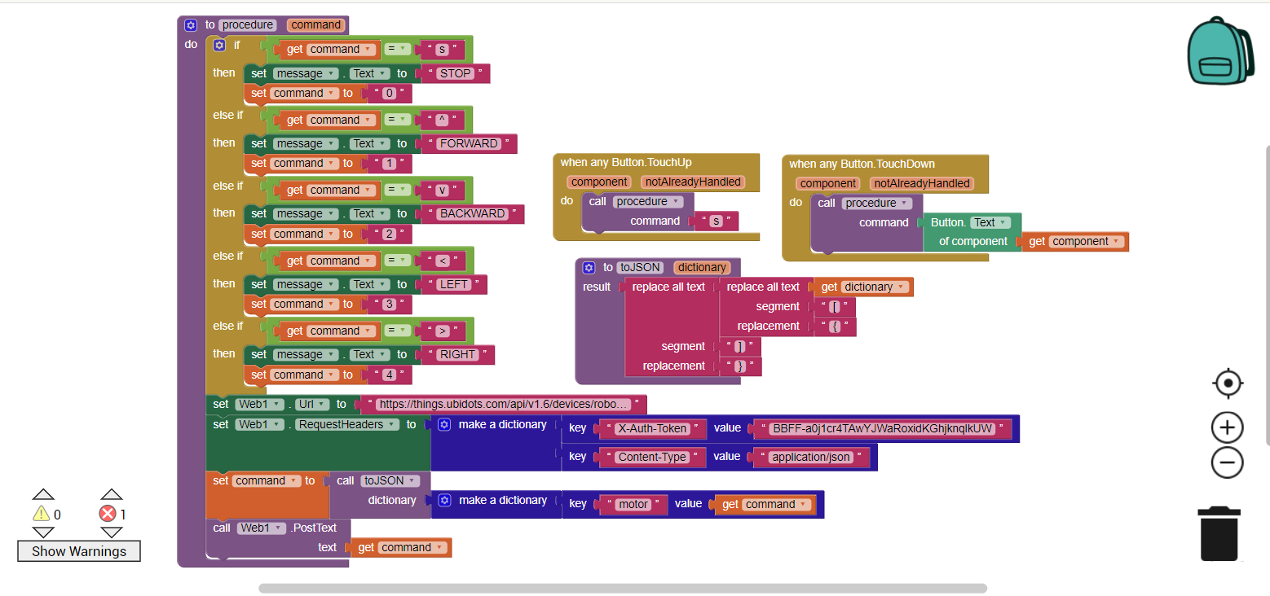

**Outcome:**

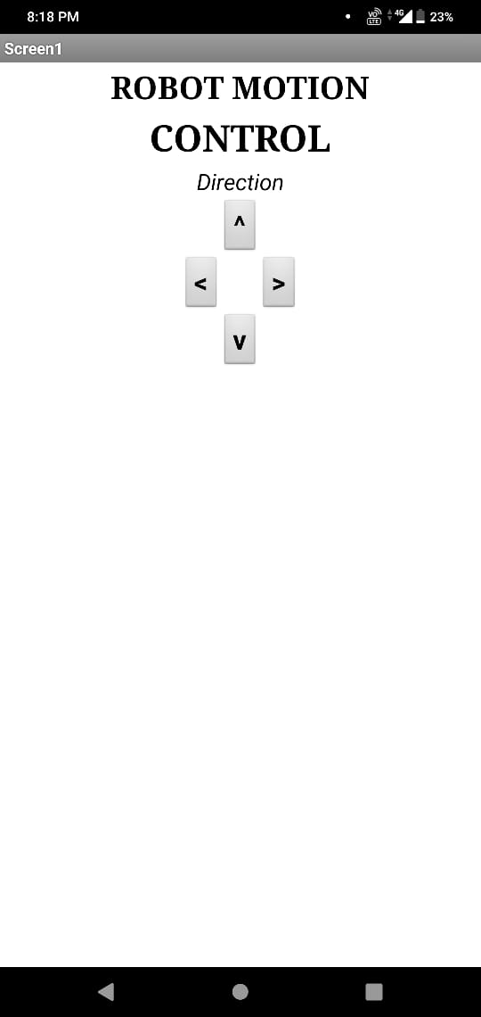

# WORKSHEET-7

**Task:**

Develop human vitals monitoring and alert system using IoT analytics platform.

## Requirements:

* PC with Arduino
* Connecting Wires
* Breadboard
* DOIT ESP32 DEVKIT V1
* 10uF Electrolytic Capacitor
* Wire Clipper
* USB Type A to Micro USB Cable
* DC 5V Power Supply
* DC 3.3V Power Supply
* DS18B20

**Code:**

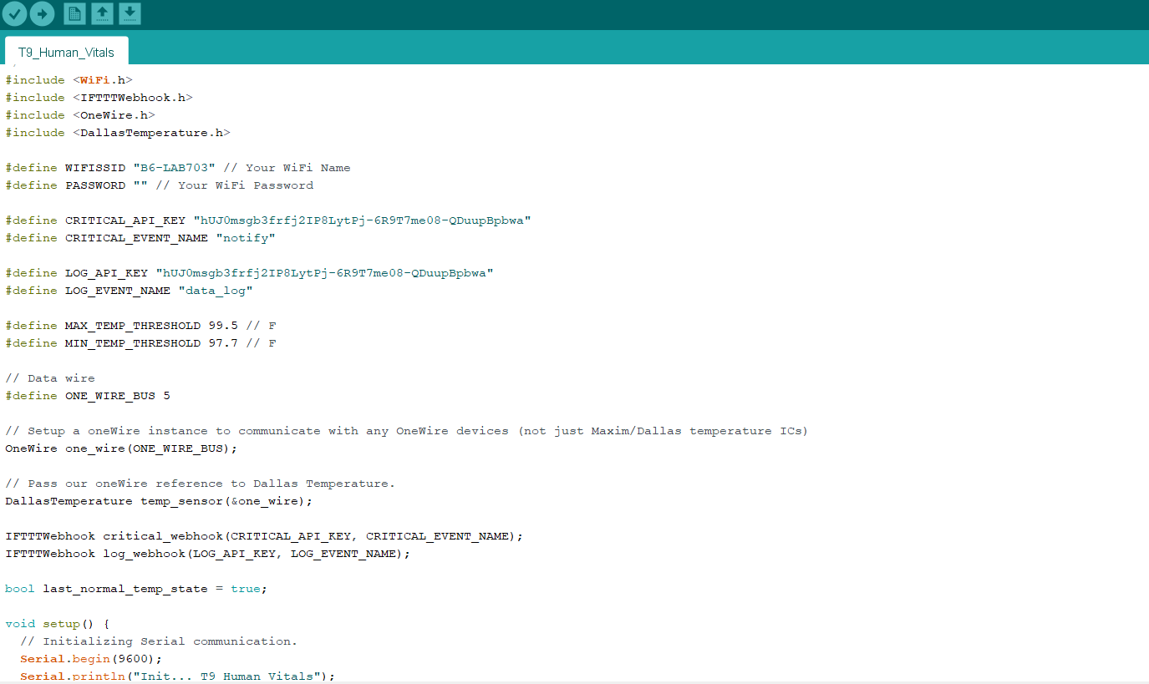

**Outcome:**

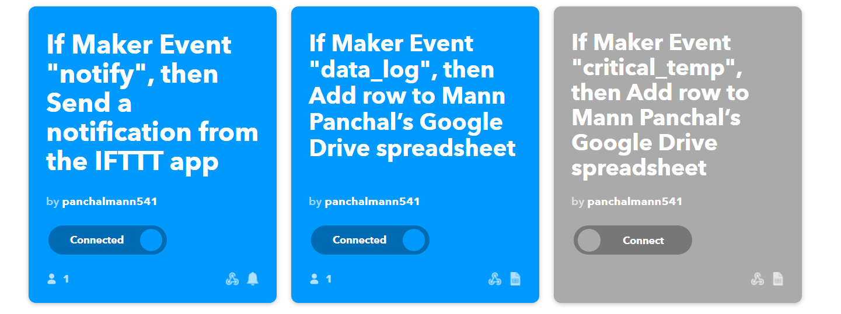

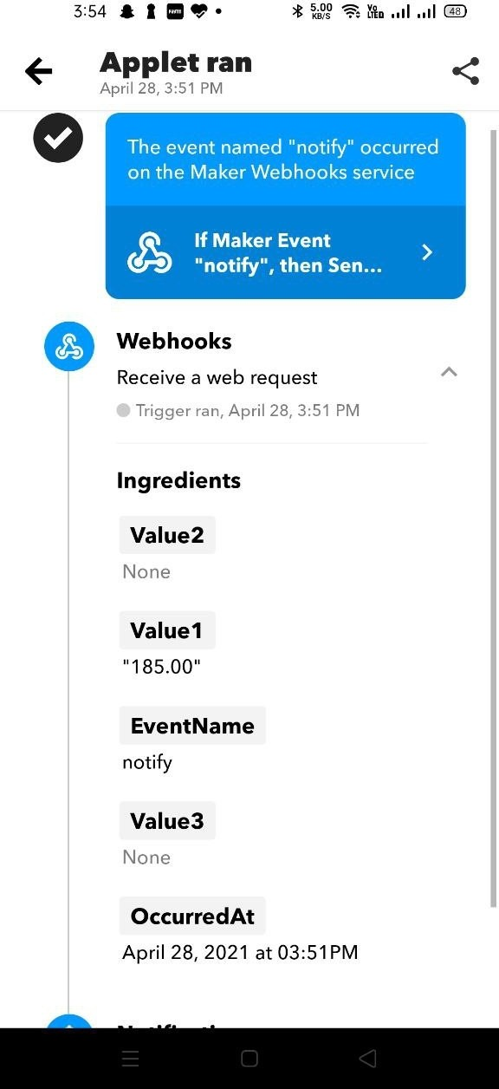

# WORKSHEET-8

**Task:**

Design a wireless network signal strength logging system for IoT devices.

## Requirements:

* PC with Arduino
* Connecting Wires
* Breadboard
* DOIT ESP32 DEVKIT V1
* 10uF Electrolytic Capacitor
* Wire Clipper
* USB Type A to Micro USB Cable
* DC 5V Power Supply
* DC 3.3V Power Supply

**Code:**

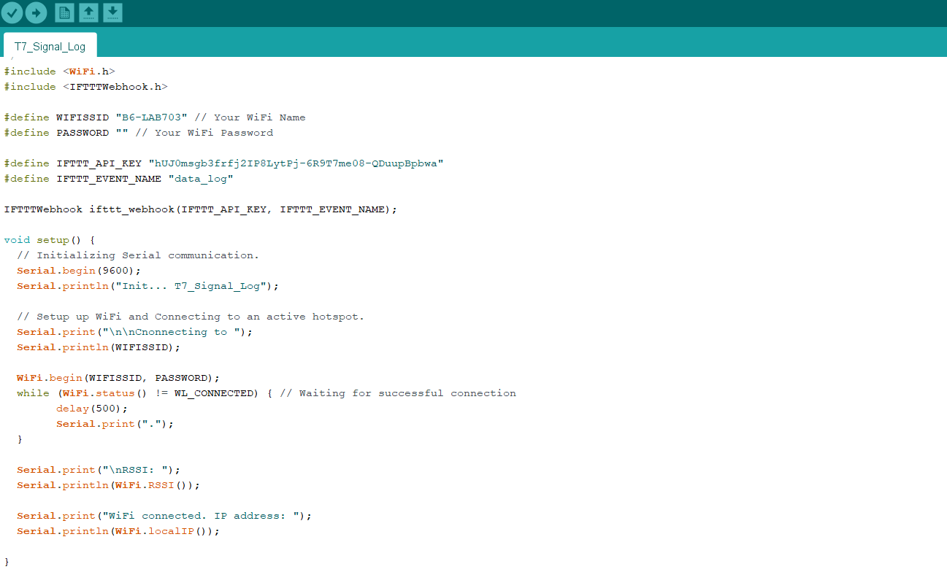

**Outcome:**

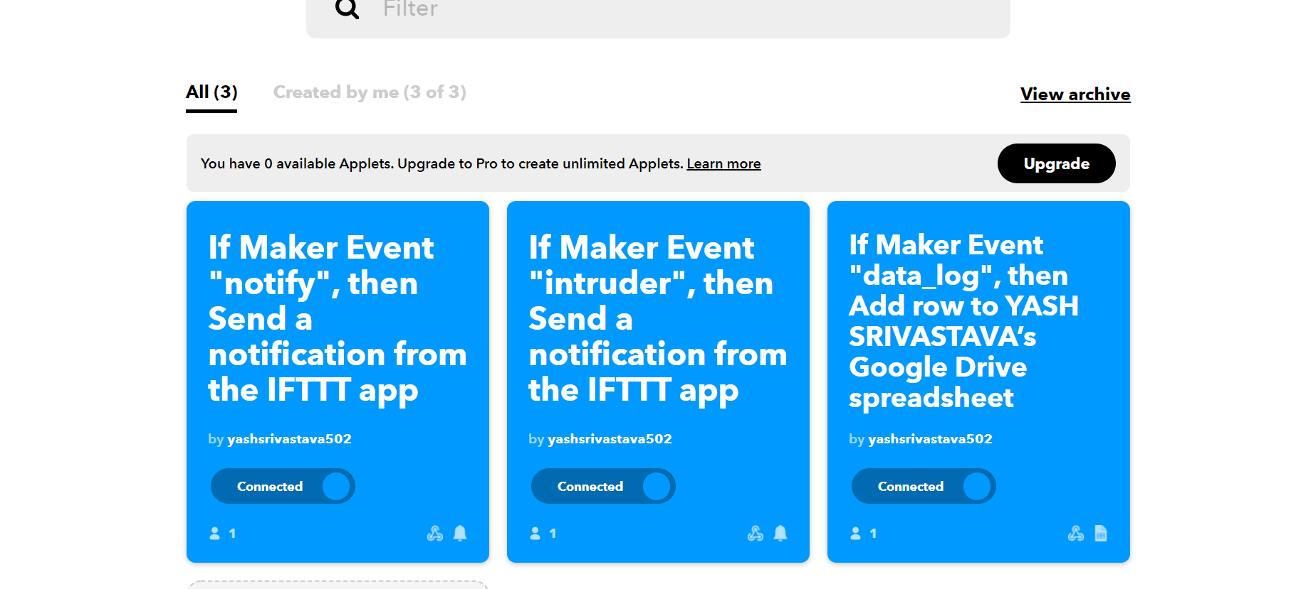

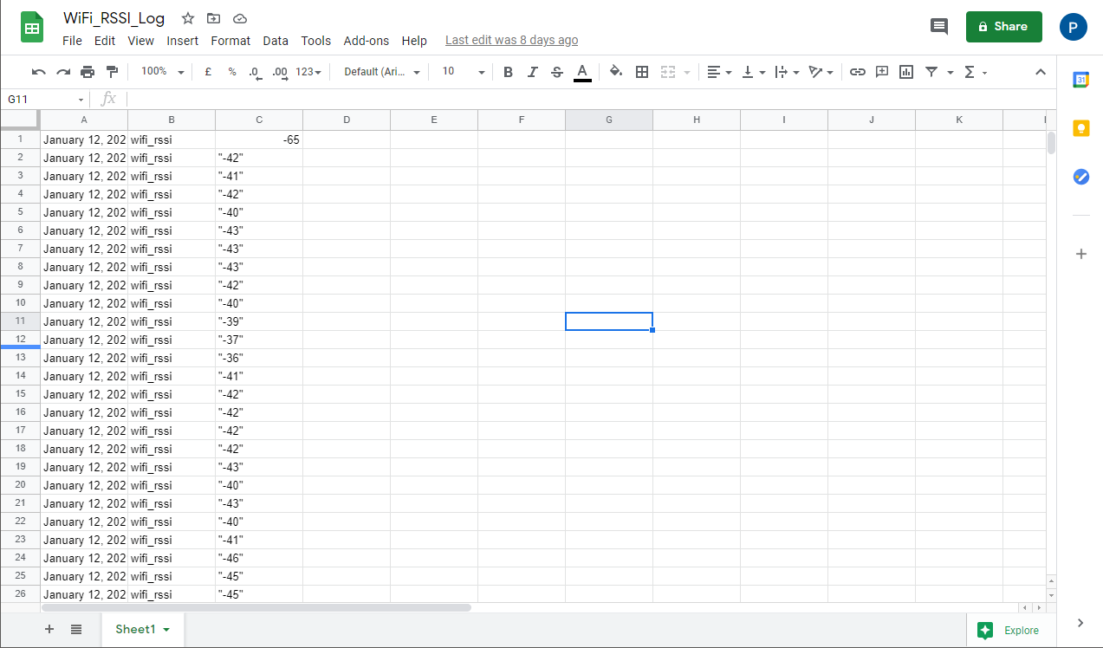

# WORKSHEET-9

**Task:**

Develop an IoT based intruder detection and alert system.

## Requirements:

* PC with Arduino, Connecting Wires, Breadboard, DOIT ESP32 DEVKIT V1, 10uF Electrolytic Capacitor, Wire Clipper, USB Type A to Micro USB Cable, DC 5V Power Supply, DC 3.3V Power Supply, HC-SR04

**code:**

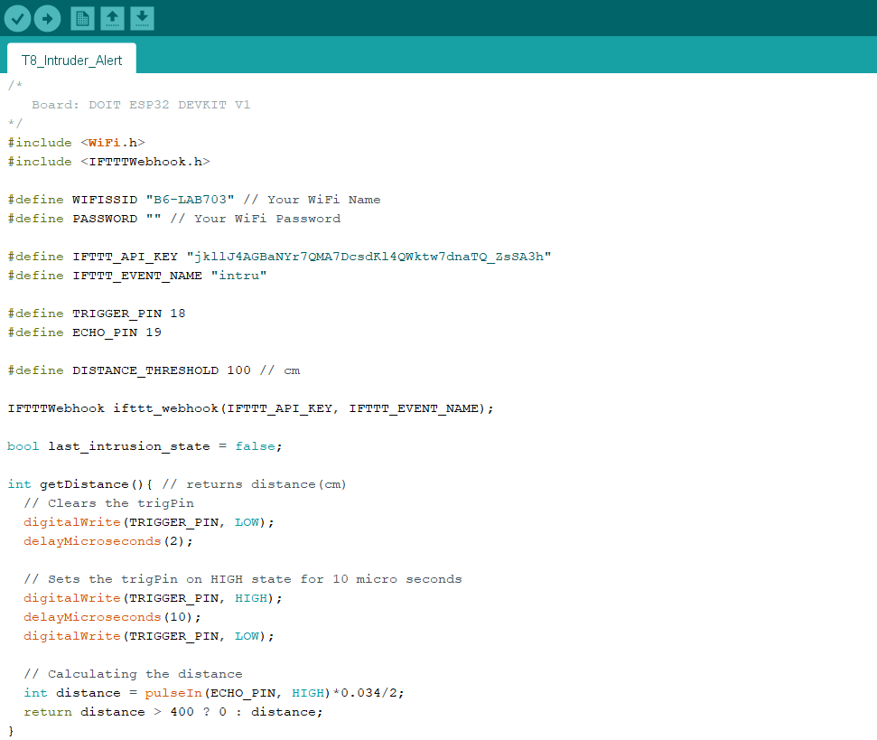

**Outcome:**

